Mrs. Wolbert’s First Grade Classroom

First Grade General Information Packet

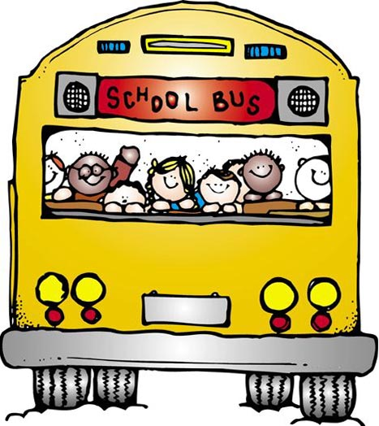
Hello! Welcome to Mrs. Wolbert’s classroom! First grade is going to be an exciting academic year for your child. It is the most important year in your child’s academic growth. First grade will be the base of your child’s entire future learning. Your child will come into first grade barely able to read and leave a full-fledged reader. This year you will be amazed and proud of the rapid progress you child will make. In order for this year to be a success, I need your help and constant support at home. In school, I have prepared an organized and structured environment to best promote your child’s academic growth, I hope the following information will help you to better understand how our classroom will be managed and make a smooth and successful year. At home your child needs 10-11 hours of sleep each night to have a productive and successful day at school.
DISMISSAL PROCEDURE
Walkers: Walkers are dismissed at 3:11 p.m. You may pick your child up in the lobby. If someone other than you is picking up your child, you MUST give me a note (in the morning) stating who has permission to pick up your child. I cannot release your child without a note. If another family member or friend will be picking up your child on a random or regular basis, please send me a note as soon as possible letting me know that you give permission for your child to go home with this person in the event you are not at the dismissal area.
*Please note:
1. Please try to be on time, in the event you are running very late, please call the main office.
2. No student is permitted to go on a bus that is not their assigned transportation. This is district policy and includes riding for sleepovers, parties, and babysitting.
Busers: After dropping off the walkers our class will walk out to the buses.
*Please note: If you child will NOT be taking the bus on a particular day and you will be picking up your child, a note must be sent in.
LUNCH
Please label all lunch boxes/paper bags with your child’s name. If you are sending lunch money to school for your child’s account, please place all money in an envelope or zip=lock bag with your child’s name on it. Also, it is important that you let your child know what he/she should be ordering for lunch, so he/she can move his/her lunch clip to the proper spot. The monthly breakfast/lunch menu is posted at the school website at: www.tidioutecharter.com
SNACKS
Please supply your child with one healthy snack and drink each day. Your child cannot buy snack during this time; therefore, you must supply snack and water. The children will eat their snacks in the afternoon, since we have an early lunch. Please, give your child one small healthy child-size snack and water. Healthy snacks are fruits, vegetables, cheese and crackers, pretzels, fruit snacks, granola bars, etc. I feel it is important to instill healthy eating habits at a young age and that there are numerous benefits to eating healthy. Please, send your child’s snack in a labeled separate bag from his/her lunch.
ABSENSES
If your child is absent, you need to send in an absent note stating the reason for your child’s absence. Please send in the note the day your child returns to school. If your child is absent, I suggest that you request your child’s missed work be sent to the office for you or another child to pick up at the end of the day. Also, it is important for you to help your child make up all the work that he/she would be missing. We do not give busy work in first grade and therefore most of the learning is teacher directed.
LATENESS/EARLY DEPARTURES
If your child has to leave school early for any reason, a note should be sent to school that morning, so that your child will be packed up in time. If the nurse is sending your child home sick, you do not need to send in a note. Lateness and early departures are recorded on your child’s records.
LABELING
Please label everything your child brings to school. All items (jackets, backpacks, lunch boxes, snacks, notebooks, crayons, etc.) need to have your child’s name on them.
CLASSROOM PLAN
The classroom plan is a set of rules for the classroom. The plan is reviewed the first day of school and sent home with the students. I review the rules with students each day in the beginning of the year. They are as follows:
- Follow Directions
- Keep hands, feet, and objects to yourself
- Respect the property and feelings of others

However, if a student breaks a rule, the following steps will be taken:
1st time a student breaks a rule: Warning
2nd time: 5 minutes off recess
3rd time: 10 minutes off recess
4th time: Phone call home or note home & no recess
5th time: Send to Principal
Severe disruption: Send to Principal

HOMEWORK POLICY

Every week your child will receive a homework worksheet on Monday. This will tell you the homework for the week and may also contain reminders about special events. If a regular homework assignment is missed, the child must complete it during recess.

READING CHALLENGE

Our district has a school wide reading challenge program every year. Your student will be challenged to read a number of pages each marking period. They will receive a reading challenge reading log. More information about this will be coming home soon. Our librarian is in charge of this activity. She will be tracking and handing out prizes. This is not a classroom activity; it is a school wide program. The grade level that reads the most pages earns a party and prizes at the end of the year.

BOOK ORDERS

Scholastic book order forms are sent home about once a month on Mondays and are due back on the written due date. Two to five Scholastic order forms will be stapled together with a parent letter. I encourage you to take advantage of these affordable books by quality authors. Through your orders, we receive free books for the classroom. Please don’t feel obligated to order. Many book order forms will be sent home throughout the year. If you would like the books you order to be a surprise gift for your child, please send a note along with the book order. I will be glad to leave the order for you in the office or send it home in a large sealed envelope.

FAMILY SITUATIONS

I would like to be informed of important experiences that may be affecting your child’s state of mind, such as: an illness in the family, a best friend moving away, conflicts among family members, loss of a pet, etc. Although I am interested in anything that could be affecting your child, it is not necessary for you to reveal personal information. Please let me know anything you do say will be kept in the strictest confidence.

HOW TO CONTACT ME

The best way to contact me during the school day is to email me at jwolbert@tidioutecharter.com, I try to check this email every day at lunch time. Or you can call the Main office and leave a message and phone number where I can reach you.

THE FIRST GRADE WEBSITE

The first grade website contains information, pictures, and links to cool stuff for first grade. Please, check out the website by visiting the classroom pages on our tidioutecharter.com website.

CLASS SCHEDULE

Our schedule is included in the “Important First Grade Information Folder” and is on the first grade website. Specials are the classes like gym and music.

I look forward to working closely with you to insure a most enjoyable, successful year for your child. Thank you in advance for your support.

